ECE 4655 Assignment 1 Report

In this lab, I wrote a basic script to read an image file, compute a basic histogram equalization, and output the modified image along with some graphs of the histograms. The concept was straightforward, and most of what I learned was just implementation for MATLAB.

Methods
Using the built in imread() function, each test image was loaded into an matrix. A simple loop over the entire image created the initial histogram of values from 0-255. Following that, another loop created the cumulative distribution by adding the elements from the base histogram. The cumulative probability was computed from that and used to generate the equalized histogram. Finally, using the equation in the text, a new image was written with the modified values from the equalized data, and printed to screen.

Issues
My issues were primarily with adjusting to MATLAB. However, after this project, I think I have a much better grasp of how to work the program. I was unable to make a fully functioning program via MATLAB.
Other issues I noticed were some artifacts in the images, especially the spinal x-ray. I had black pixels peppering the adjusted areas, but that appears to be an issue with the base equation not fitting to that image very well. Otherwise the adjustments look similar to the examples in the book.

Top Row: left: image 3.16(1), middle: 3.16(1) with just a contrast stretch for comparison,
right: 3.16(1) with Histogram Equalization

Middle Row: image 3.09 before and after Equalization
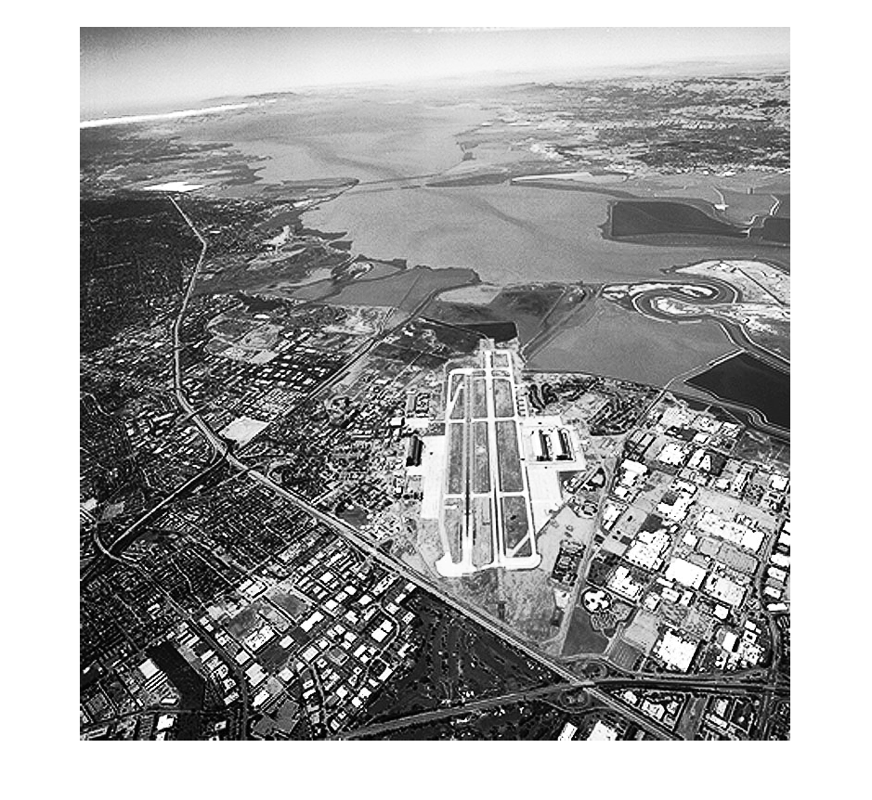
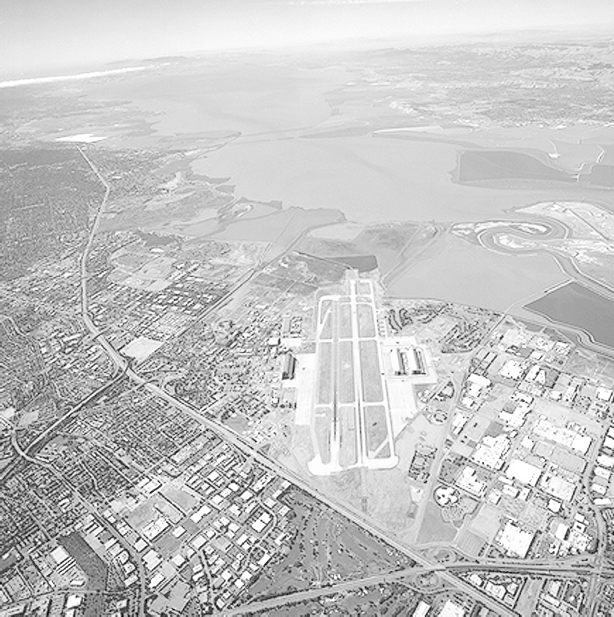
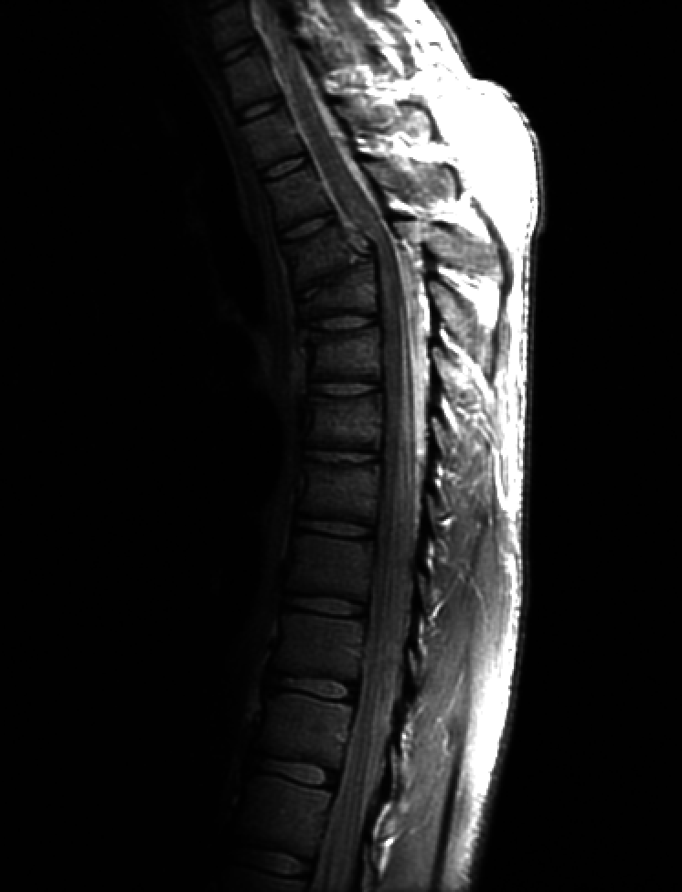
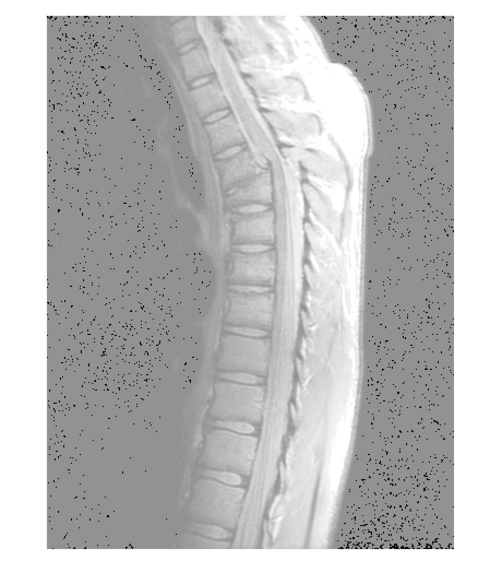
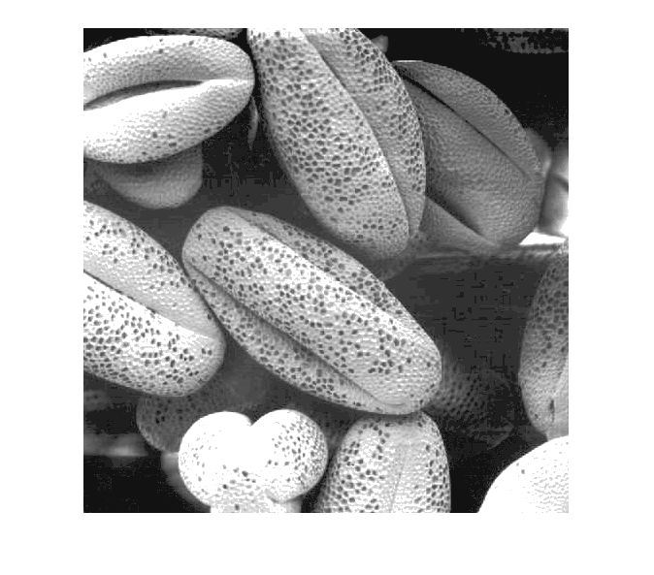
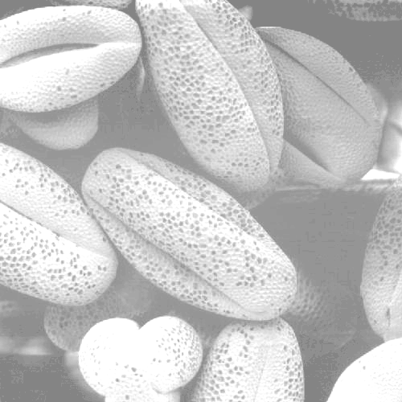
Bottom Row: figure 3.08 before and after Equalization
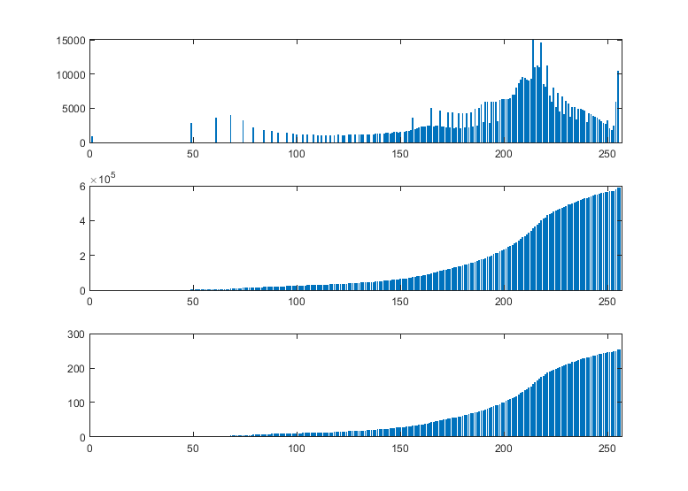
Image 3.09 Top: Value Histogram. Middle: Cumulative Histogram. Bottom: Equalized Histogram
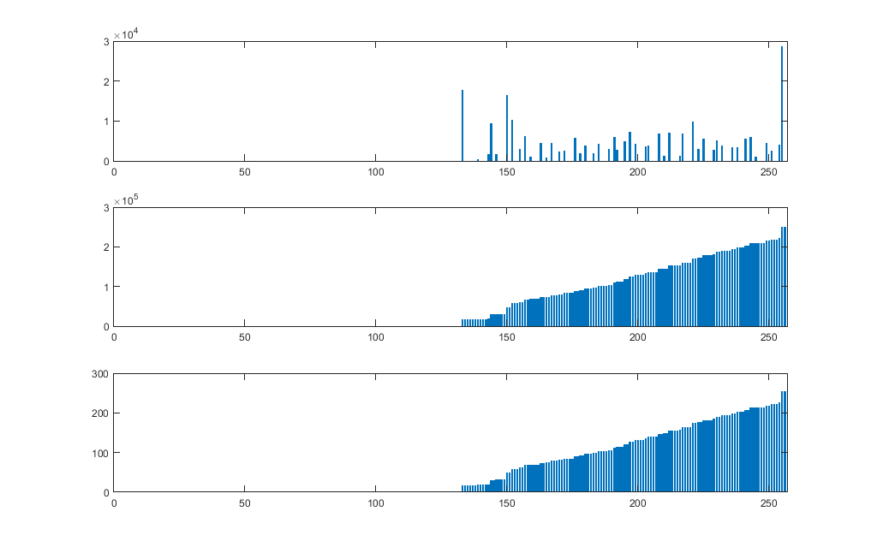
Image 3.16(1) Top: Value Histogram. Middle: Cumulative Histogram. Bottom: Equalized Histogram
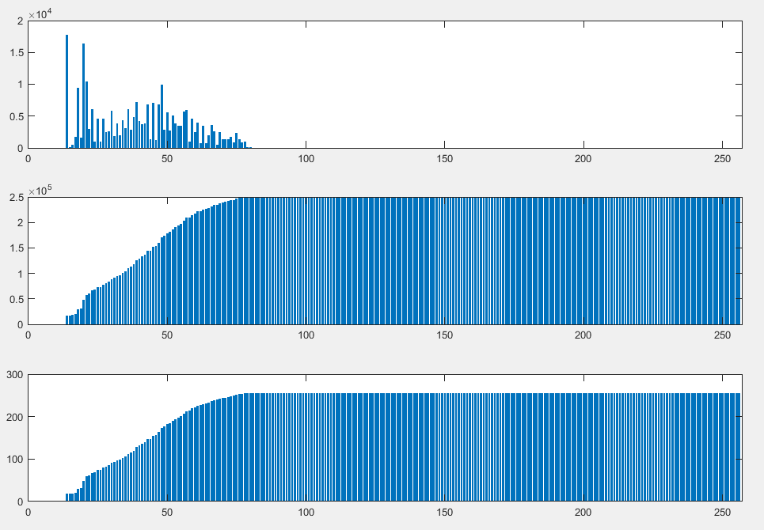
Image 3.16(4) Top: Value Histogram. Middle: Cumulative Histogram. Bottom: Equalized Histogram
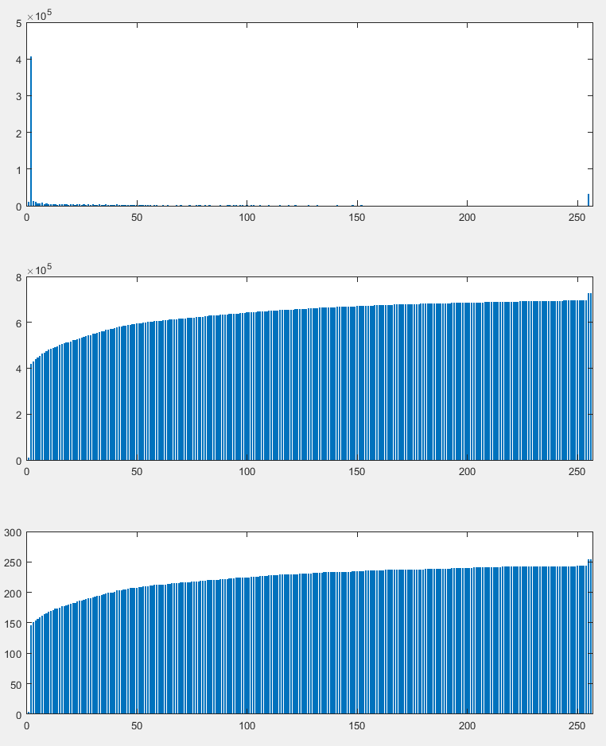
Image 3.08 Top: Value Histogram. Middle: Cumulative Histogram. Bottom: Equalized Histogram

